**Requirement Specification and Collection Document for Events Database**

**Introduction**

The purpose of this document is to specify the requirements for the design and development of an events database. The database will be used to store information about events, tickets, users, orders, payments, and reviews.

**User Requirements**

* The database must store information about events, including the event name, date, time, location, and user ID of the event organizer.
* The database must store information about tickets, including the ticket type, price, and the event ID that the ticket belongs to.
* The database must store user information, including the user ID, first name, last name, email, phone number, and password hash.
* The database must store information about payments, including the payment ID, payment method, payment status, and order ID that the payment belongs to.
* The database must store information about reviews, including the review ID, rating, review text, and the user ID and event ID that the review belongs to.
* The database must store information about orders, including the order ID, order date and order time.

**E.R Diagram**

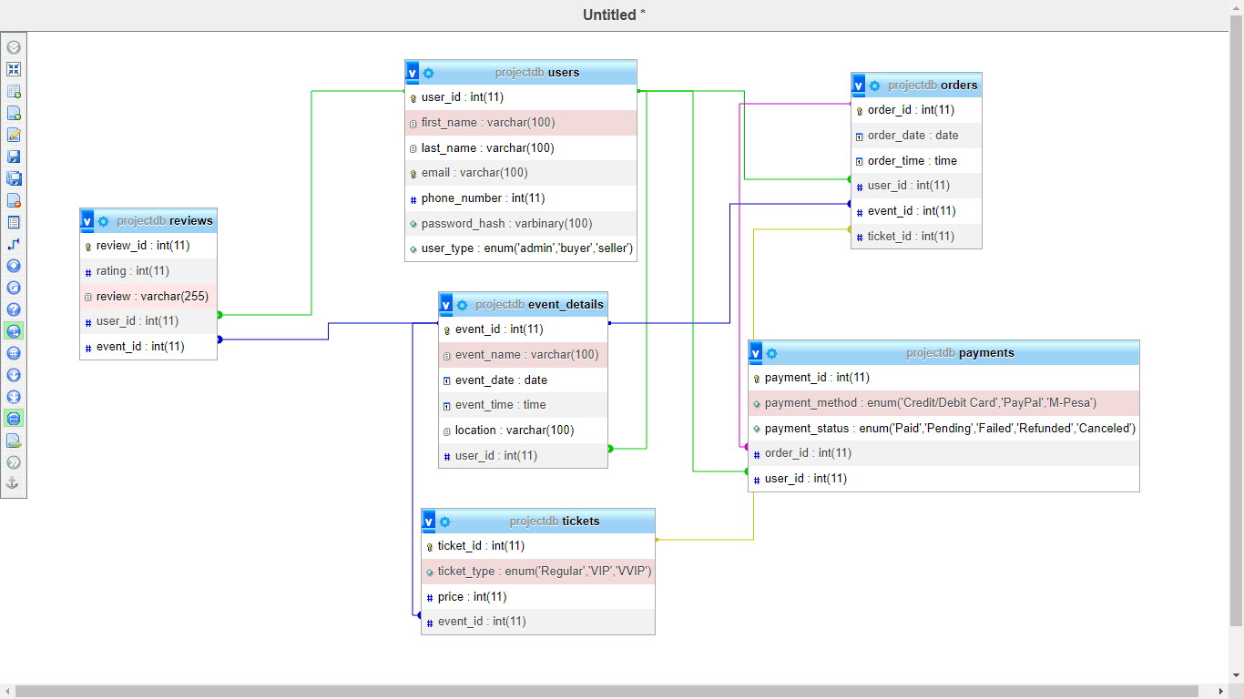

Name,event,payment status query = SELECT first_name, last_name, event_name, payment_status FROM users JOIN event_details JOIN payments

**TABLES**

1. **Users table**: This table stores the information of all users of the application. The columns include user_id (primary key), first_name, last_name, email, phone_number, password_hash, and user_type. The user_id is a unique identifier for each user, and the email is also unique as it is used for authentication. The user_type column specifies whether a user is an admin, buyer or seller.
2. **Events table**: This table stores the details of all events organized by the application. The columns include event_id (primary key), event_name, date, time, location, and user_id (foreign key). The user_id column references the user who created the event
3. **Tickets table:** This table stores the details of all tickets available for each event. The columns include ticket_id (primary key), ticket_type, price, and event_id (foreign key). The event_id column references the event for which the ticket is being sold.
4. **Orders table**: This table stores the details of all orders made by users. The columns include order_id (primary key), order_date, order_time, and user_id (foreign key). The user_id column references the user who placed the order.
5. **Payments table**: This table stores the details of all payments made by users. The columns include payment_id (primary key), payment_method, payment_status, and order_id (foreign key). The order_id column references the order for which the payment was made.
6. **Reviews table**: This table stores the reviews made by users for events they attended. The columns include review_id (primary key), rating, and review. The rating column stores a numeric value between 1 and 5, while the review column stores a textual review of the event.